Microsoft Azure - Starter Kits for Partners

Power BI Knowledge Base and FAQ

Last Update: Aug 2016





**MICROSOFT MAKES NO WARRANTIES, EXPRESS, IMPLIED OR STATUTORY, AS TO THE INFORMATION IN THIS DOCUMENT.**

The information contained in this document represents the current view of Microsoft Corporation on the issues discussed as of the date of publication. Because Microsoft must respond to changing market conditions, it should not be interpreted to be a commitment on the part of Microsoft, and Microsoft cannot guarantee the accuracy of any information presented after the date of publication.

Complying with all applicable copyright laws is the responsibility of the user. Without limiting the rights under copyright, no part of this document may be reproduced, stored in or introduced into a retrieval system, or transmitted in any form or by any means (electronic, mechanical, photocopying, recording, or otherwise), or for any purpose, without the express written permission of Microsoft Corporation.

Microsoft may have patents, patent applications, trademarks, copyrights, or other intellectual property rights covering subject matter in this document. Except as expressly provided in any written license agreement from Microsoft, the furnishing of this document does not give you any license to these patents, trademarks, copyrights, or other intellectual property.

The descriptions of other companies’ products in this document, if any, are provided only as a convenience to you. Any such references should not be considered an endorsement or support by Microsoft. Microsoft cannot guarantee their accuracy, and the products may change over time. Also, the descriptions are intended as brief highlights to aid understanding, rather than as thorough coverage. For authoritative descriptions of these products, please consult their respective manufacturers.

© 2014 Microsoft Corporation. All rights reserved. Any use or distribution of these materials without express authorization of Microsoft Corp. is strictly prohibited.

Microsoft and Windows are either registered trademarks of Microsoft Corporation in the United States and/or other countries.

The names of actual companies and products mentioned herein may be the trademarks of their respective owners.

Contents

Top questions 6

I need help signing up for Power BI 6

What if my data isn't up to date? 6

I get an error refreshing data with the Power BI Personal Gateway. 6

The AS Connector won't install or I can't connect to data. 6

Top issues by Power BI features 6

Connect to services 6

**Problem with authenticating Power BI model to Azure SQL DW** 6

**How to access last 1 year’s data from Google Analytics** 7

Power BI Desktop 7

**Problem with extracting demographic information from Facebook** 7

**Date Filtering - Start of Current Year to Today** 9

**Function convert in Power BI** 10

**Get data from an Access DB** 11

Dashboards/Reports 11

**How to filter data based on user logged in?** 11

**PowerBI + SSRS 2016 to Power BI** 11

**Power Bi services does not work now with RLS** 12

Share your work 13

**Share Power BI report** 13

**Dashboard on screen on shared computer** 13

Data refresh 13

**Can’t refresh a Dataset from Excel file** 13

**Gateway Data Refresh** 14

**What is the best way to replicate data from Azure VM** 14

Gateways 15

**Confused about SQL Server, Enterprise Gateway and publishing reports from Power BI Desktop** 15

**How to choose the right Gateway for multiple sources in Power BI?** 15

**Enterprise Gateway Error. SSAS Data Source** 16

**Cannot refresh due to Gateway issue** 17

**How to sign in another account in PBI gateway?** 17

**Sharing enterprise gateway or on premises gateway** 18

Administration 18

**How to change Power BI language to other language while maintaining regional settings?** 18

**Problem with sharing dashboard to free user** 18

Troubleshooting 19

**Whenever I log into the Power BI service I encounter 'Sorry, we couldn't find that report'** 19

**Refresh Now and Scheduled Refresh Not Working** 20

**Connect to Service Manager DWDataMart** 21

# Top questions

## I need help signing up for Power BI

If you get an error message when signing up for Power BI, please consult these [common errors and workarounds](https://support.powerbi.com/knowledgebase/articles/594453-self-service-signup-for-power-bi).

## What if my data isn't up to date?

If your dashboards or reports aren't showing your latest data, here are some things to check.

* **﻿**﻿**﻿Make sure you've set up refresh.**Follow [these instructions to set up scheduled refresh or start a one-time "refresh now"](https://support.powerbi.com/knowledgebase/articles/474669-refresh-data-in-power-bi).
* **Is your data stored in OneDrive?**﻿Power BI checks OneDrive for changes to your data once an hour.  If you need the data sooner, you can click "REFRESH NOW", but only once every five minutes.  Learn more about [refresh for data in OneDrive](https://support.powerbi.com/knowledgebase/articles/471009-refresh-excel-csv-and-power-bi-desktop-files-sto).
* **Are your tiles out of date?**﻿Tiles for direct query data sources are refreshed once every ten minutes.

## I get an error refreshing data with the Power BI Personal Gateway.

Please take a look at our [Personal Gateway troubleshooting guide](https://support.powerbi.com/knowledgebase/articles/666367-troubleshooting-power-bi-personal-gateway) for more information.

## The AS Connector won't install or I can't connect to data.

Please read the [Analysis Services Connector troubleshooting guide](https://support.powerbi.com/knowledgebase/articles/505324-troubleshooting-power-bi-analysis-service-connecto).

# Top issues by Power BI features

There are some real show cases which Power BI users are asking in Power BI Community. The questions are categorized by Power BI features in the following sections.

## Connect to services

### **Problem with authenticating Power BI model to Azure SQL DW**

**Problem description**

The user established a connection to an Azure SQL DW instance with Power BI desktop and the credentials are working in desktop.

When publishing to PBI Service it asks for the credentials again for the data source. The error message "The credentials you provided for the data source are invalid. Please check the credentials for all the data sources."

**Solution**

Make sure that you have chosen the Yes for Windows Azure Services to Connect to your database when configuring the Firewall rules. ‘Yes’ is the default option. As the image below:

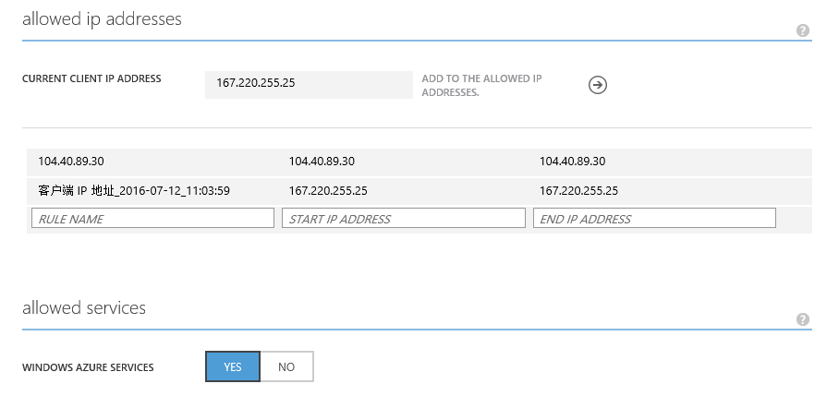

**Community Link**

<http://community.powerbi.com/t5/Service/Problems-authenticating-data-source-with-Azure-SQL-Data/m-p/52382>

### **How to access last 1 year’s data from Google Analytics**

**Problem description**

How to obtain one year’s data from Google Analytics? Is there a way to import data for the selected time period?

**Solution**

In Power BI Service, we almost can't do anything about the data model. While the Power BI Desktop is a design tool, and provide more features for us to play with the data model.

When you connect to [Google Analystic content pack](https://powerbi.microsoft.com/en-us/documentation/powerbi-content-pack-google-analytics/), you will get a dashboard and report that provide insights about your site traffic and user dimensions based on the imported data set. If you want to filter year, you need to place the year field in [report/page/visual level filter](https://powerbi.microsoft.com/en-us/documentation/powerbi-service-add-a-filter-to-a-report/) to filter specific year.

If you want to edit the query or modify data retrieved from Google Analytic, you need to design the report in Power BI Desktop, then publish it to Power BI Service. For more information, see: [Third-party service: Google Analytics connector for Power BI Desktop](https://powerbi.microsoft.com/en-us/documentation/powerbi-service-google-analytics-connector/).

**Community Link**

<http://community.powerbi.com/t5/Integrations-with-Files-and/How-to-access-last-1year-data-from-Google-Analytics/m-p/55571>

## Power BI Desktop

### **Problem with extracting demographic information from Facebook**

**Problem Description**

When trying to extract and visualize the facebook demographic information.

But all the breakdowns expand on columns and not as rows.

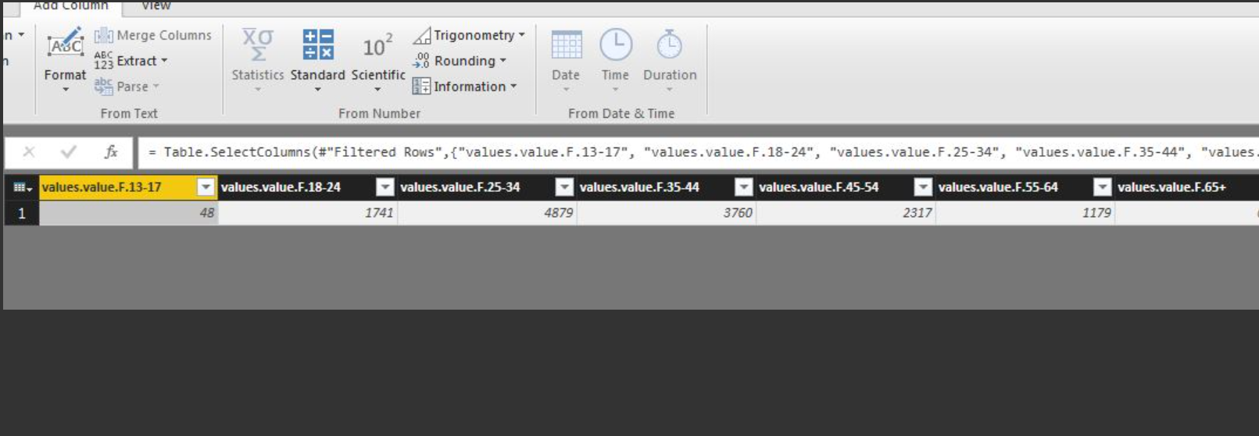

When transposing the data, all the column header information was lost.

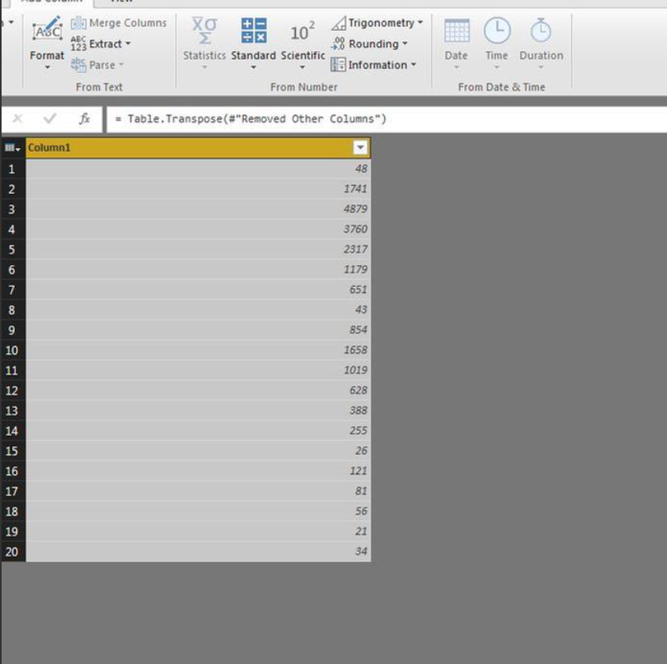

**Solution**

In this scenario, you need to treat header row as first data row of table, then transpose rows and columns. Please follow steps below:

1. Check "Use Headers as First Row" option.

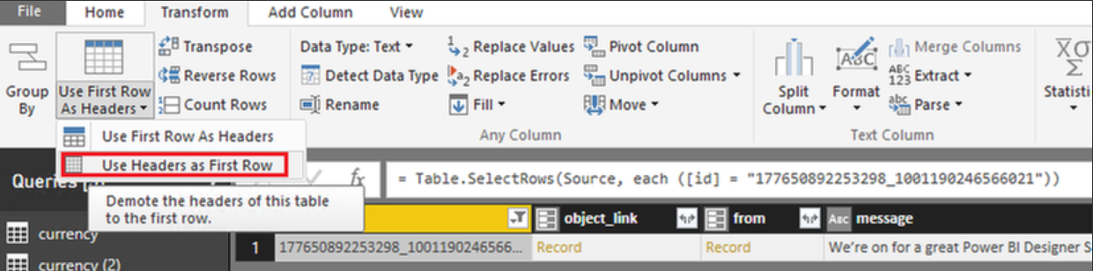

2. Click Transpose button.

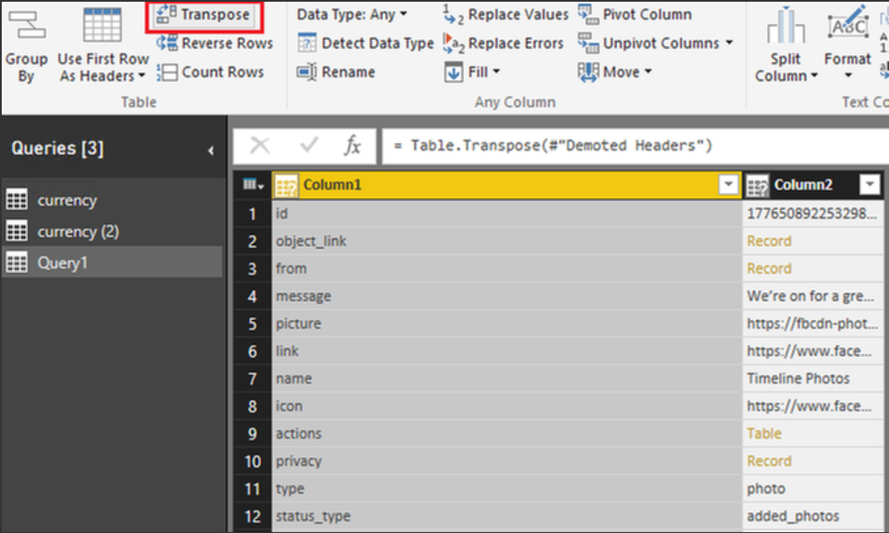

**Community Link**

<http://community.powerbi.com/t5/Desktop/Facebook-Power-BI-report-Video-Attached/m-p/33318#M11792>

### **Date Filtering - Start of Current Year to Today**

**Problem description:**

You are trying to produce a budget-based report comparing budget to sales.

In the budget table, you have budgets for each month for 2016. You would like to filter the report so it only displays budget amounts from the start of the year up until the current month.

The budget_table has fields for Year, MonthNo, MonthName, BudgetAmount, and Date - with Date being the date of the end of the month.

**Solution:**

In this scenario, as the budget table contains data for 2016, you can create a new column to dataset to tell which row is before current month with the DAX expression like below:

Before_current_month = IF( [Month]<=MONTH(Now()),"before_current_month","")

Then use this new column “Before_current_month” in filters. For more information, please refer to this article: [Finding the Latest Date in Power BI Desktop](https://blogs.msdn.microsoft.com/lukaszp/2015/08/08/finding-the-latest-date-in-power-bi-desktop/).

**Community Link**

<http://community.powerbi.com/t5/Desktop/Date-Filtering-Start-of-Current-Year-to-Today/m-p/27900>

### **Function convert in Power BI**

**Problem description:**

You are trying to assign the data to a unit of measure (kgs, lbs, tons) and also like to convert them.

**Solution:**

There are trans and rates tables as below:

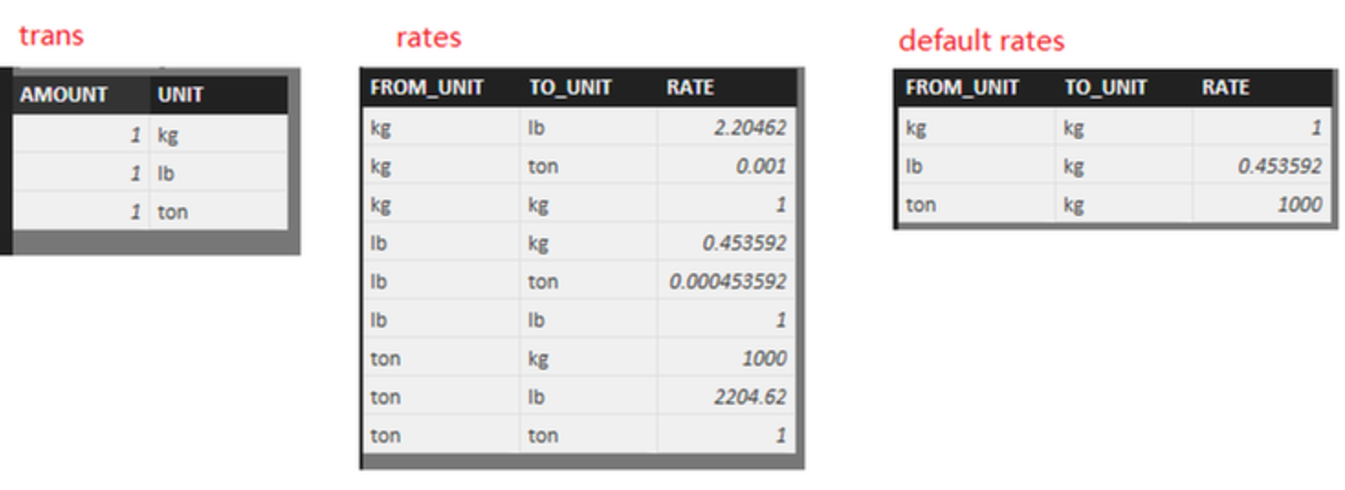

Create a measure as

|  |
| --- |
| Total Mass =  IF (  ISFILTERED ( Rate[TO_UNIT] ) && HASONEVALUE ( Rate[TO_UNIT] ),  SUMX ( Trans, Trans[AMOUNT] * LASTNONBLANK ( Rate[RATE], "" ) )  & " "  & LASTNONBLANK ( Rate[TO_UNIT], "" )  & "s",  SUMX ( Trans, Trans[AMOUNT] * LASTNONBLANK ( 'Default Rate'[RATE], "" ) )  & " "  & LASTNONBLANK ( 'Default Rate'[TO_UNIT], "" )  & "s"  ) |

Then use a Slicer to determine the converting UNIT. By default, it shows as kgs.

**Community Link**

<http://community.powerbi.com/t5/Desktop/Function-convert-in-Power-BI/m-p/53586>

### **Get data from an Access DB**

## Dashboards/Reports

### **How to filter data based on user logged in?**

**Problem description**

Generally, the visualization cannot circumvent existing polices, or apply another set of security policies on top of those already implemented at the data source.

For example, a visualization of sales data needs to reflect the policy that account managers can only read sales data for their region.

**Solution**

Row-level security (RLS) with Power BI can be used to restrict data access for given users. Filters restrict data at the row level. You can define filters within roles.

You can now configure RLS for data models imported into Power BI with Power BI Desktop. You can also configure RLS on datasets that are using DirectQuery, such as SQL Server. Previously, you were only able to implement RLS within on-premises Analysis Services models outside of Power BI. For Analysis Services live connections, you configure Row-level security on the on-premises model. The security option will not show up for live connection datasets. More details can be found at <https://powerbi.microsoft.com/en-us/documentation/powerbi-admin-rls/>

**Community Link**

<https://community.powerbi.com/t5/Service/How-to-filter-data-based-on-user-logged-in/td-p/19432>

### **PowerBI + SSRS 2016 to Power BI**

**Problem Description**

You have created a SSRS chart and trying to Pin to Power BI Dashboard. When trying to click on power BI icon on top of the report, it shows an error message says "You don’t have any dashboardsClose You need at least one dashboard that you have permissions to pin to."

**Solution**

Please check if you have group workspace created.

<https://msdn.microsoft.com/en-us/library/mt604784.aspx>

**Community Link**

<http://community.powerbi.com/t5/Integrations-with-Files-and/PowerBI-SSRS-2016-to-Power-BI/m-p/51195>

### **Power Bi services does not work now with RLS**

**Problem Description**

You have updated RLS with your dashboard which was upload via a connection to one drive.

The problem is the dashboard does not display any data with RLS on, works fine without RLS

Here is the error in details:

Couldn't load the data for this visual

Couldn't retrieve the data for this visual. Please try again later.

Please try again later or contact support. If you contact support, please provide these details.

Http Status Code401

 Activity IDef753658-979e-4301-8eb9-c1e43c3cfcc4

 Correlation ID0a87e174-990d-21fb-2469-27cf4b5f6eb4

 Request ID14cf42d6-464a-69b3-88e9-8d4d36d8bd22

 TimeFri Aug 05 2016 14:40:14 GMT+0100 (GMT Summer Time)

 Version13.0.1500.566

 Cluster URIhtxxs://wabi-north-europe-redirect.analysis.windows.net

**Solution**

If I don’t add one of my colleague to the role, he will get the error message you mentioned when viewing the report that I share with him.

It is recommended to check that if you have added the user as a member to the role you created(as shown in the following screenshot), and test the role by selecting the ellipse (...) next to the role in Power BI Service to check if it works as expected.

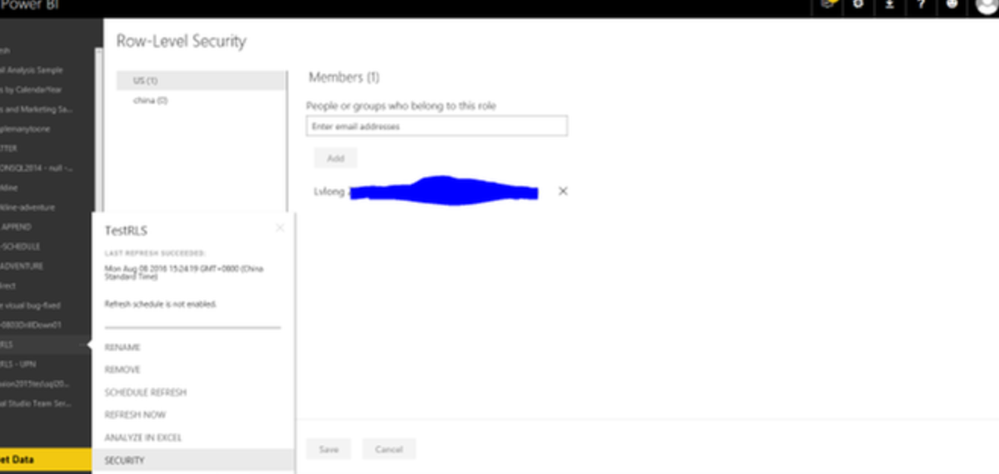

**Community Link**

<http://community.powerbi.com/t5/Service/Power-Bi-services-does-not-work-now-with-RLS/m-p/56100>

## Share your work

### **Share Power BI report**

**Problem Description**

You have a report in the Power BI and want to share this report to other users in diferent domain X. e.g [rakesh@x.com](mailto:rakesh@x.com) earlier it was amit@z.com.

When i use the email to add in the group, it says, "These email addresses does not exist in your organization”.

**Solution**

You can share a dashboard with the other domain account. Please follow the second link ( [Share a dashboard with colleagues and others](https://powerbi.microsoft.com/en-us/documentation/powerbi-service-share-unshare-dashboard/) ) which suggested by [@sdjensen﻿](http://community.powerbi.com/t5/user/viewprofilepage/user-id/4508) to complete the task.

Please note the other domain account can't reshare the dashboard. And they see the shared dashboard in its own browser window without the left navigation pane, not in their usual Power BI portal. They have to bookmark the link to access this dashboard in the future.

**Community Link**

<http://community.powerbi.com/t5/Service/PowerBI-Report-Sharing/m-p/42688>

### **Dashboard on screen on shared computer**

**Problem Description**

The screen is on a remote desktop that a couple of users have access to.

Is it possible to show the dashboard without giving all the other users access to your office 365 account?

**Solution**

No, it's not possible. In Power BI Services, the dashboards must be shared to users.

In this secnario, your users suppose to log in the shared computer with their own credentials, so each user is still using a different account to log in Power BI Services. You have to give the access to that dashboard for all users.

You don't need to concern too much about the privacy because each user can only view that dashboard. They can't edit or access other data under your account.

**Community Link**

<http://community.powerbi.com/t5/Service/Dashboard-on-screen-on-shared-computer/m-p/60338>

## Data refresh

### **Can’t refresh a Dataset from Excel file**

**Problem Description**

You have uploaded an .xls file(with Power Pivot data models and Power Query connections to csv and xls files) to OneDrive and from there to Power BI, but the data set is not refreshable. When you click on ‘Schedule Refresh’, an error message pops out:

*‘You cannot schedule refresh for this dataset because it does not contain data model connections. You cannot schedule refresh on worksheet connections or linked tables. To schedule refresh the data must be loaded into the data model.’*

**Solution**

The error message indicates that the Power Query only write back to Excel not Data Model. When you click on the ‘Load To’ option on the Power Query, also choose ‘Add it to Data Model’.

**Community Link**

<https://community.powerbi.com/t5/Integrations-with-Files-and/Can-t-refresh-a-Data-Set-from-Excel-file/td-p/2285>

### **Gateway Data Refresh**

**Problem Description**

The queries use the "Today" filter on the date column.

This seems to be the only way to automatically retrieve the data for TODAY, this does not seem possible when done in the report/dashboard itself.

This "Seems" to be the issue with the data not refreshing correctly.

You have to open the reports in Desktop, refresh and publish every day. From then on the data is nicely updated via the direct query/gateway throughout the day.

When tomorrow comes, the data set does not update and the reports are stuck on the previous day’s data until you refresh and re-publish again.

Assuming this is the expected behavior then how do we set the filter in the reports to only show date from "Today" without having to re-filter the data manually. Is there any efficient way to do this?

**Solution**

You can consider adding a calculated column for tagging "Today" or not.

|  |
| --- |
| TodayOrNot = IF(Table[Date]=TODAY(),"Today","Not Today") |

Then you can create a slicer with this column.

**Community Link**

<http://community.powerbi.com/t5/Service/Gatwway-Data-Refresh/m-p/58335>

### **What is the best way to replicate data from Azure VM**

**Problem description:**

You have an Azure Server set up and have SQL Server 2014 installed. Is there a method to refresh my Power BI datasets directly to my Azure Server? Or is it simply a matter of installing the Enterprise Gateway?

**Solution**

We are not able to directly connect to the SQL instance from Power BI Service.

However, we can firstly connect to SQL Server on Azure VM from Power BI Desktop, create reports and then publish the PBIX file to Power BI Service. In order to schedule refresh for the dataset, we will need to install personal gateway or on-premises gateway and add data source to the installed gateway.

**Community Link**

<http://community.powerbi.com/t5/Integrations-with-Files-and/What-is-the-best-way-to-replicate-data-from-Azure-Server/m-p/58590>

## Gateways

### **Confused about SQL Server, Enterprise Gateway and publishing reports from Power BI Desktop**

**Problem description:**

Here is the situation:

1. You have a report which was developed in Power BI Desktop.

2. The sources of data are in house SQL server databases.

3. Publish this report to Power BI Service.

4. The refresh is scheduled once a day.

5. No gateways installed.

6. Daily scheduled-refresh works fine if the desktop computer remains turned on. Scheduled-refresh fails if the computer is turned off.

As this report is designed for other users to view, how to make sure the report updates when the computer is turned off?

Look at the enterprise gateway, however it seems you set up the datasets for other users to access using Power BI online rather than linking to those sources when you create your data model in power bi desktop. The questions are:

-How to make sure that the dashboard which uses in house SQL Server data will refresh overnight if the local computer is turned off?

- If you need to install a gateway on a server that is fine, but then how to link to those now cloud based SQL Server datasets when constructing your report/dashboard in Power BI Desktop?

**Solution**

In this scenario, as data source is SQL Server database, you need to configure gateway to enable the connection between Power BI service and SQL Server database. When you refresh the report, you need to make sure both servers host Enterprise gateway and SQL Server database is on.

It seems that the Enterprise gateway is installed on the laptop, and SQL Server database is on another server. If that is a case, when the laptop is turned off, not connected to the Internet, or asleep the gateway won't work and the data in the cloud service will not be synchronized with your on-premises data. So the schedule refresh will be failed at this time.

**Community Link**

<http://community.powerbi.com/t5/Integrations-with-Files-and/Confused-about-SQL-Server-Enterprise-Gateway-and-publishing/m-p/60323>

### **How to choose the right Gateway for multiple sources in Power BI?**

**Problem description:**

You have a Power BI desktop with two sources: one from a local file and one from OneDrive file.

When you upload the desktop to the Power BI online. There is a problem.

Configure the Gateway and the data source and everything is ok. When going to the dataset configuration the option is disabled.

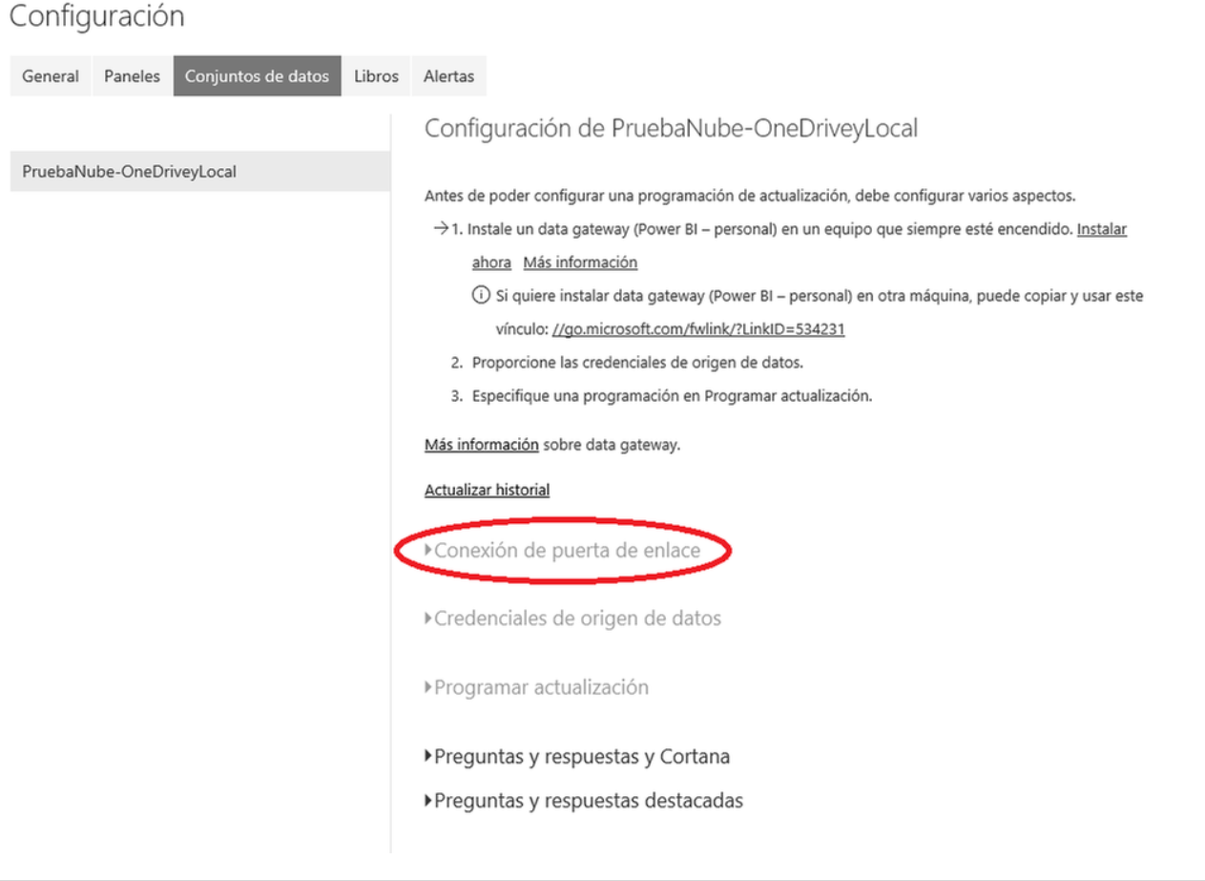

**Solution:**

In this scenario, you need to install and configure the personal gateway. You can download the [On-premises data gateway](http://go.microsoft.com/fwlink/?LinkID=820925), then select Personal Gateway instead of On-premises data gateway to install the personal gateway. Then the Gateway connection option will be available.

Reference:  
[Gateway connection](https://powerbi.microsoft.com/en-us/documentation/powerbi-refresh-scheduled-refresh/#gateway-connection)

**Community Link**

<http://community.powerbi.com/t5/Integrations-with-Files-and/Multiple-sources-in-Power-BI/m-p/54705>

### **Enterprise Gateway Error. SSAS Data Source**

**Problem description:**

There is a problem when creating a new data source to connect to local SSAS server.

The error code: *DM_GWPipeline_Gateway_UnsupportedServerVersion*

Error Details: *"The gateway does not support the version of the specified data source. Please make sure to check the list of supported data sources, install the latest version of the gateway or upgrade your data source to a newer version."*

Version of SQL Server : 2012 with CU 4 for SP1

Installed the latest On-premises Data Gateway.

Version: 13.0.1500.472

The SSAS server is installed locally on the laptop. The gateway is also installed locally.

**Solution:**

As the error message mentioned, the version of your connecting SSAS server is not supported. Power BI only supports SSAS 2012 or later. In this scenario, your SSAS may not upgrade to 2012 SP1 CU4, even your Database Engine is 2012 SP1 CU4. Please check your SSAS version, see: [How to determine the version, edition and update level of SQL Server and its components](https://support.microsoft.com/en-us/kb/321185).

**Community Link**

<http://community.powerbi.com/t5/Service/Enterprise-Gateway-Error-SSAS-Data-Source/m-p/53716>

### **Cannot refresh due to Gateway issue**

**Problem description:**

Receive the below error message when trying to enable ‘schedule refresh’ on dataset generate with Power BI Desktop on on-premises data.

*Failed to update data source credentials: The credentials you provided for the data source are invalid. Please check the credentials for all the data source.*

*Activity ID: 35c1de71-5524-5a44-f98b-8e6e5e4649bf*

*Request ID:3ee4c2a7-9f01-903d-a0dc-8cad06ff0a88*

*Status code:200*

**Solution:**

In Power BI service under setting icon click settings -> Dataset -> Data source credentials and make sure you've signed in there. Also click the dropdown on "Gateway connection" to make the personal - gateway loaded and connected to current dataset. Then edit the "Data source credentials" successfully.

**Community Link**

<http://community.powerbi.com/t5/Desktop/gateways/m-p/47629>

### **How to sign in another account in PBI gateway?**

**Problem Description**

When setting the Enterprise Gateway, you can only automatically sign in with the Windows Credential as PBI services account. You will need to use another sign in account. How to change the account?

**Solution**

Currently, you can only sign in with the same Windows credentials. However, we can add other account as an admin to manage the gateway.

**Community Link**

<http://community.powerbi.com/t5/Service/How-to-sign-in-another-account-in-PBI-gateway/m-p/48926>

### **Sharing enterprise gateway or on premises gateway**

**Problem Description**

The user has installed the latest Power BI Gateway and want to other user can connect the data and use the gateway.

**Solution**

In order to have other users to get use of the on premises gateway, in order to update their own data, the following should be done:

1. Checking connections for the Gateway under Power BI Service-Gear->Manage GateWays (under your Browser, once installed, the gateway would show up as connected);
2. Add the User’s Database or Data sources as a data source under your configured gateway through Power BI service;
3. Add the User to the User list, in order to use the data source to create or update report;
4. Optional, you could also add that user as the gateway admin, which would allow him to manage gateway settings;

For detailed steps, please see the SQL server data source as a reference:

<https://powerbi.microsoft.com/en-us/documentation/powerbi-gateway-enterprise-manage-sql/>

**Community Link**

<http://community.powerbi.com/t5/Service/Sharing-enterprise-gateway-or-on-premises-gateway/m-p/49230>

## Administration

### **How to change Power BI language to other language while maintaining regional settings?**

**Problem description:**

How to change Power BI language to other language while maintaining regional settings?

**Solution:**

Read this post to find out how to change Power BI language: <https://powerbi.microsoft.com/da-dk/documentation/powerbi-supported-languages/>

**Community Link**

<https://community.powerbi.com/t5/Service/change-PowerBI-language-menus-to-english-while-maintaining/td-p/4782>

### **Problem with sharing dashboard to free user**

**Problem description:**

The free user cannot see the Power BI mobile dashboards which contains Power BI Pro content.

**Solution:**

In your scenario, it seems that the dashboard contains the Power BI Pro content, so when you share the dashboard with free users, they can't see the dashboard content. Please check if there are any dashboard content belong to Pro content. For more information, please refer to this article: [Power BI Pro content - what is it?](https://powerbi.microsoft.com/en-us/documentation/powerbi-power-bi-pro-content-what-is-it/).

Besides let free users upgrade to Pro users, to work around the issue, you can delete Pro content from the dashboard to let free users access.

**Community Link**

<http://community.powerbi.com/t5/Service/Want-to-get-back-to-free-version/m-p/53142>

## Troubleshooting

### **Whenever I log into the Power BI service I encounter 'Sorry, we couldn't find that report'**

**Problem description:**

Whenever you log into the Power BI service I get the error message 'Sorry, we couldn't find that report'.

Then just click 'Ok' and everything functions and refreshes as normal. Everything is functioning without issue it's just this annoying message every time you log into the service.

After searching through every report and every visualization is working as expected. Tried deleting all the datasets, the reports and dashboards and starting again but this pesky error message just won't go.

**Solution:**

Please follow steps below to troubleshoot the issue:

1. How did you access the Power BI Service? Generally, we use this URL to access it: [http://powerbi.microsoft.com](http://powerbi.microsoft.com/). Please try it again use this URL.

2. Did the error throw out frequently? Before the issue occurred, did you perform any action for dataset, report or dashboard?

3. Please publish the report from Power BI Desktop to Power BI Service, then click the URL below to access Power BI Service to see if the error throws out.

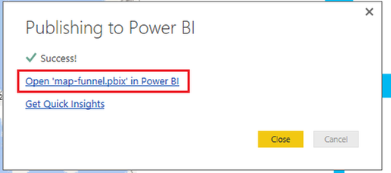

4. Please use [Fiddler](https://www.telerik.com/download/fiddler/fiddler4) to monitor the traffic when you access Power BI Service.

**Community Link**

<http://community.powerbi.com/t5/Service/Whenever-I-log-into-the-Power-BI-service-I-encounter-Sorry-we/m-p/54451>

### **Refresh Now and Scheduled Refresh Not Working**

**Problem description:**

There are issues with Scheduled Refresh. The first issue is as follows:

* Power BI would not refresh in the morning. Out last refresh at 11pm would work, but then nothing would refresh the following day unless you manually went in and click 'Refresh Now'.

The second issue as of today is as follows:

* 'Refresh Now' no longer runs. When you click it a notification appears for half a second saying that a refresh is happening and disappears, however the refresh does not complete. Usually there would be a loading indicator next to the dataset name - this is also not here.

Right now the only way of updating the data is me refreshing the Power BI Desktop file and publishing.

**Solution:**

In this secnario, I suggest you check the logs first.

You can see On-premises data gateway service logs under:

*C:\Users\PBIEgwService\AppData\Local\Microsoft\on-premises data gateway\Gateway*.log*

And **On-premises data gateway service** event logs  under **Application and Services Logs**.

Then please restart enterprise gateway service via command:

net stop PBIEgwService

net start PBIEgwService

If the issue still persists, I suggest you uninstall Enterprise gateway and install latest version On-premises data gateway. For more details, please see: [Troubleshooting the On-Premises Data Gateway](https://powerbi.microsoft.com/en-us/documentation/powerbi-gateway-onprem-tshoot/)

**Community Link**

<http://community.powerbi.com/t5/Service/Refresh-Now-and-Scheduled-Refresh-Not-Working/m-p/53731>

### **Connect to Service Manager DWDataMart**

**Problem description:**

When you add data and select SQL Database, you are prompted for my server name and credentials.

For some reason this is very odd as when at time entering the server name you get prompted for my credentials, when that doesn’t go through. Try again and this time is doesn’t accept my server name so put in the IP address and get to the credentials screen. At time you need to add the domain in from of the server name and at times you don’t.

And you are a sysadmin on the database but when adding the credentials, it says "User does not have authorization". At times it processes the credentials and all i get is the error message:         "   ""  "

**Solution:**

Firstly, check that if you can successfully connect to the remote SQL instance from other application (such as Excel) on your Laptop.

Secondly, if you are able to connect to SQL from Excel on your Laptop, launch Power BI desktop with admin privileges, delete any SQL Server data source from "options" -> "Data source settings" in Power BI Desktop, then check if you can connect to the remote SQL. If the issue persists, please uninstall Power BI Desktop and reinstall it, then connect to SQL Server.

**Community Link**

http://community.powerbi.com/t5/Desktop/Connect-to-Service-Manager-DWDataMart/m-p/36318